Newsletter

Fall 2014

About the Foundation

The Sisters of Mercy established St. Patrick’s Mercy Home Foundation in November 1998. The Foundation’s mission is to support financially the on-going efforts of St. Patrick’s Mercy Home to provide a safe and comfortable home for its residents. A dedicated, volunteer Board of Directors manages the Foundation, which has a part-time staff person.

Since the Foundation was established, it has contributed (to the end of March 2014) $909,290.18 to the residents of St. Patrick’s Mercy Home for such items as:
- Wheelchair accessible bus
- State of the art Bathing Systems
- Modern electric beds
- Privacy Screens
- Hot meal food distribution System
- Overhead electric lifts
- Drapes for Stage in Auditorium
- Recumbent Cross Trainer
- Chapel Organ
- Renovations to Chapel
- Annual Christmas Gifts for Residents
- Blanket Warmers
- Recreation Area Furniture, Kitchen Appliances and Renovations

With the help of our benefactors, we hope to surpass the $1,000,000 milestone in donations to the residents during the current year.

Greetings from the Board Chair
Thank you for taking time to read the St. Patrick’s Mercy Home Foundation’s newsletter for this last half of 2014.
The Foundation was established by the Sisters of Mercy for the primary purpose of raising funds and managing those funds to improve the quality of life and care for those valued members of society who need to live in St. Patrick’s Mercy Home.
There are 10 Board Members who volunteer their time to oversee the work of the Foundation and who ensure financial security for the assets entrusted to the Foundation. Additional volunteers

contribute through committee work, particularly through fund development activities.
The St. Patrick’s Mercy home was opened over 50 years ago and it is not a modern building so there is a large need to improve the building in order to provide quality and safe care for more than 200 residents.
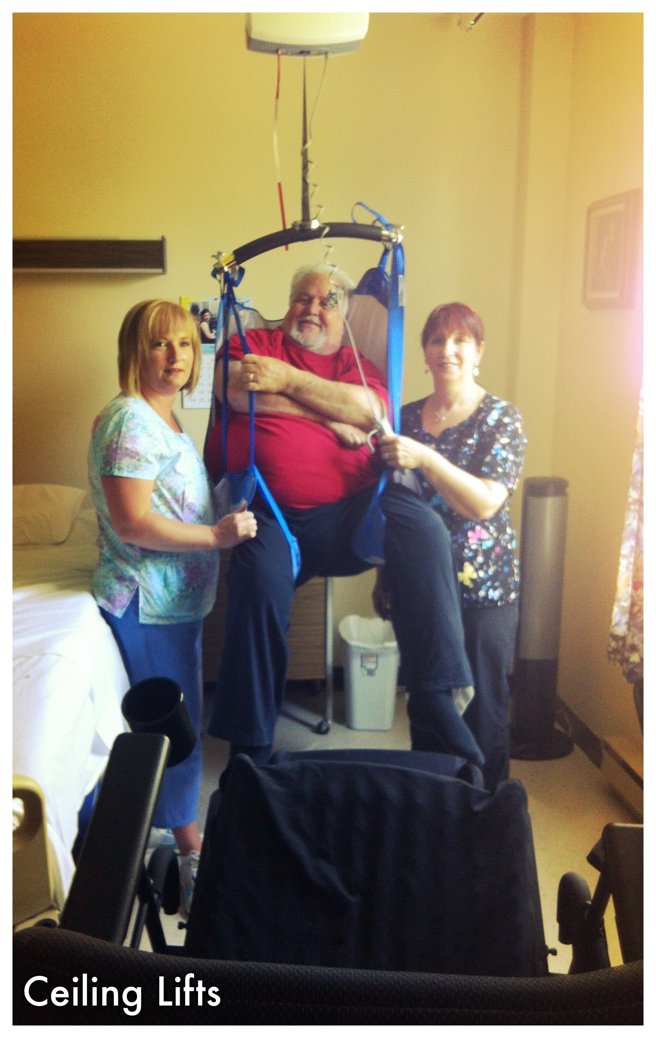
As an example of the contribution of the Foundation in recent years, the Foundation has provided grants to the Home to purchase and install 58 ceiling lifts for residents’ rooms at the Home. The electric lifts allow staff to safely transfer residents in wheel chairs to/from their beds and baths in a more dignified manner. Ceiling lifts, in general, have not been a priority for capital funding by the Eastern Health Board nor for the Provincial Department of Health but they are extremely important for the safe care of Residents. The Foundation is committed to raise funds to equip every room at the Home with this essential equipment – we will need to find funds for another 50 lifts.
There are many, many needs of older and infirm residents and we are committed to work diligently to begin to meet their needs over time.
In our Province there are many efforts being made to supplement the healthcare basics through fundraising and the Foundation asks that you consider the needs of St. Patrick’s Mercy Home Residents when you choose to support a Charity or Foundation. And, even without contributing financially, if you have a special interest in helping older persons who reside in a long term care facility, then feel free to contact us to inquire about how you can help through initiatives of the Foundation.
We are working cooperatively with staff, administration, families and volunteers to make St. Patrick’s Mercy Home a ‘real home’ to its Residents – you can help, too.

Andrew D. Butt, Chair of the SPMH Foundation Board

Upcoming Events in Support of St. Patrick’s Mercy Home

October 30, 2014
Dinner Theatre
Spirit of Newfoundland Production
Masonic Temple
This is an annual event of the Foundation and its success is a result of the tremendous support we receive from residents’ family members and friends, as well as the fabulous support we receive from the community and staff of St. Patrick’s Mercy Home.

March 26, 2015
Emerald Auction & Dinner
Holiday Inn
Please mark your calendar and support the residents of St. Patrick’s Mercy Home by attending or making a donation.

For more information please contact the Foundation Office on the First Floor or call Gerard at 752-8745

In Loving Memory

We gratefully acknowledge donations made since April 1, 2014 to St. Patrick’s Mercy Home Foundation in loving memory of:
Heber Bennett Madge Bouchier
Rita Furlong Marie Power
Henry Jordan Ivy Scammell
Nellie Rideout Hilda Tiller
Patricia Maunder William Harte
Rosella Dyer George Sullivan
Gertrude Furlong Gerald (Lindy) Luther
Lucie Besso Sarah “Jenny” Jordan
Committees of the Board
The Board is supported by the following very active committees: Finance, Fund Development.

Committee Mandates
Finance Committee provides guidance to the Foundation Board on investments, budgets and annual audit and over sees the day-to-day financial transactions of the Foundation.
Fund-development Committee raises funds used by the Foundation in support of the residents of the Home. It usually has two major fundraisers a year: Dinner Theatre and Emerald Auction & Dinner. The committee ensures all donations and donors to St. Patrick’s Mercy Home are recognized in a timely and appropriate manner in accordance with the Donor Recognition Program.
In addition, the committee provides advice and guidance to all those interested in leaving a gift to St. Patrick’s Mercy Home as part of their will or estate plan. Planned Giving will not impact your current financial circumstances but is the promise of a gift in the future.
We are always looking for helping hands!
To volunteer to serve on the Board or any of the Committees call Andrew Butt, Board Chair at
689-3496 or email andrewbutt@nl.rogers.com.

Did you Know?
The first female resident at St. Patrick’s Mercy Home was Teresa Antle from Burin. The first male resident was Mr. J. Pearson from Paradise, Placentia Bay.

The first sod for St. Patrick’s Mercy Home was turned on October 3, 1954.

You can now donate Online
Donations in support of St. Patrick’s Mercy Home can now be made online by using the secure website offered by CandaHelps.org.
All you have to do is go to the Foundation’s website and click on Contributions and the icon



then follow the instruction on this secure website.
Your donation is acknowledged and a tax receipt issued immediately. The Foundation is advised of your donation, which is then deposited in the Foundation’s bank account.

Visit our website!
http://www.spmhf.nl.ca

W
hy not make St Patrick’s Mercy Home

~Your Charity of Choice~

Creating a Home away from Home!

The Foundation Office is located on the First Floor and is open from 9:00 a.m. to 1:00 p.m., Monday to Friday.
P.O. Box 21191, 146 Elizabeth Ave.
St. John’s, NL A1A 5B2
Telephone 752-8745
Email Gerard.morris@easternhealth.ca


